The Success in Publishing Workshop
Friday, January 28 12:00-1:30 SBSG 1517

Light refreshments will be served

COR presents a workshop aimed at helping students and junior faculty better understand the process of submitting papers for publication to top-tier journals. This workshop features a panel of speakers who are editors or sit on the editorial boards for journals that publish organizational research. The workshop will focus on the editorial process, the reviewing process, and publishing strategies.

PANELISTS

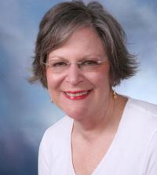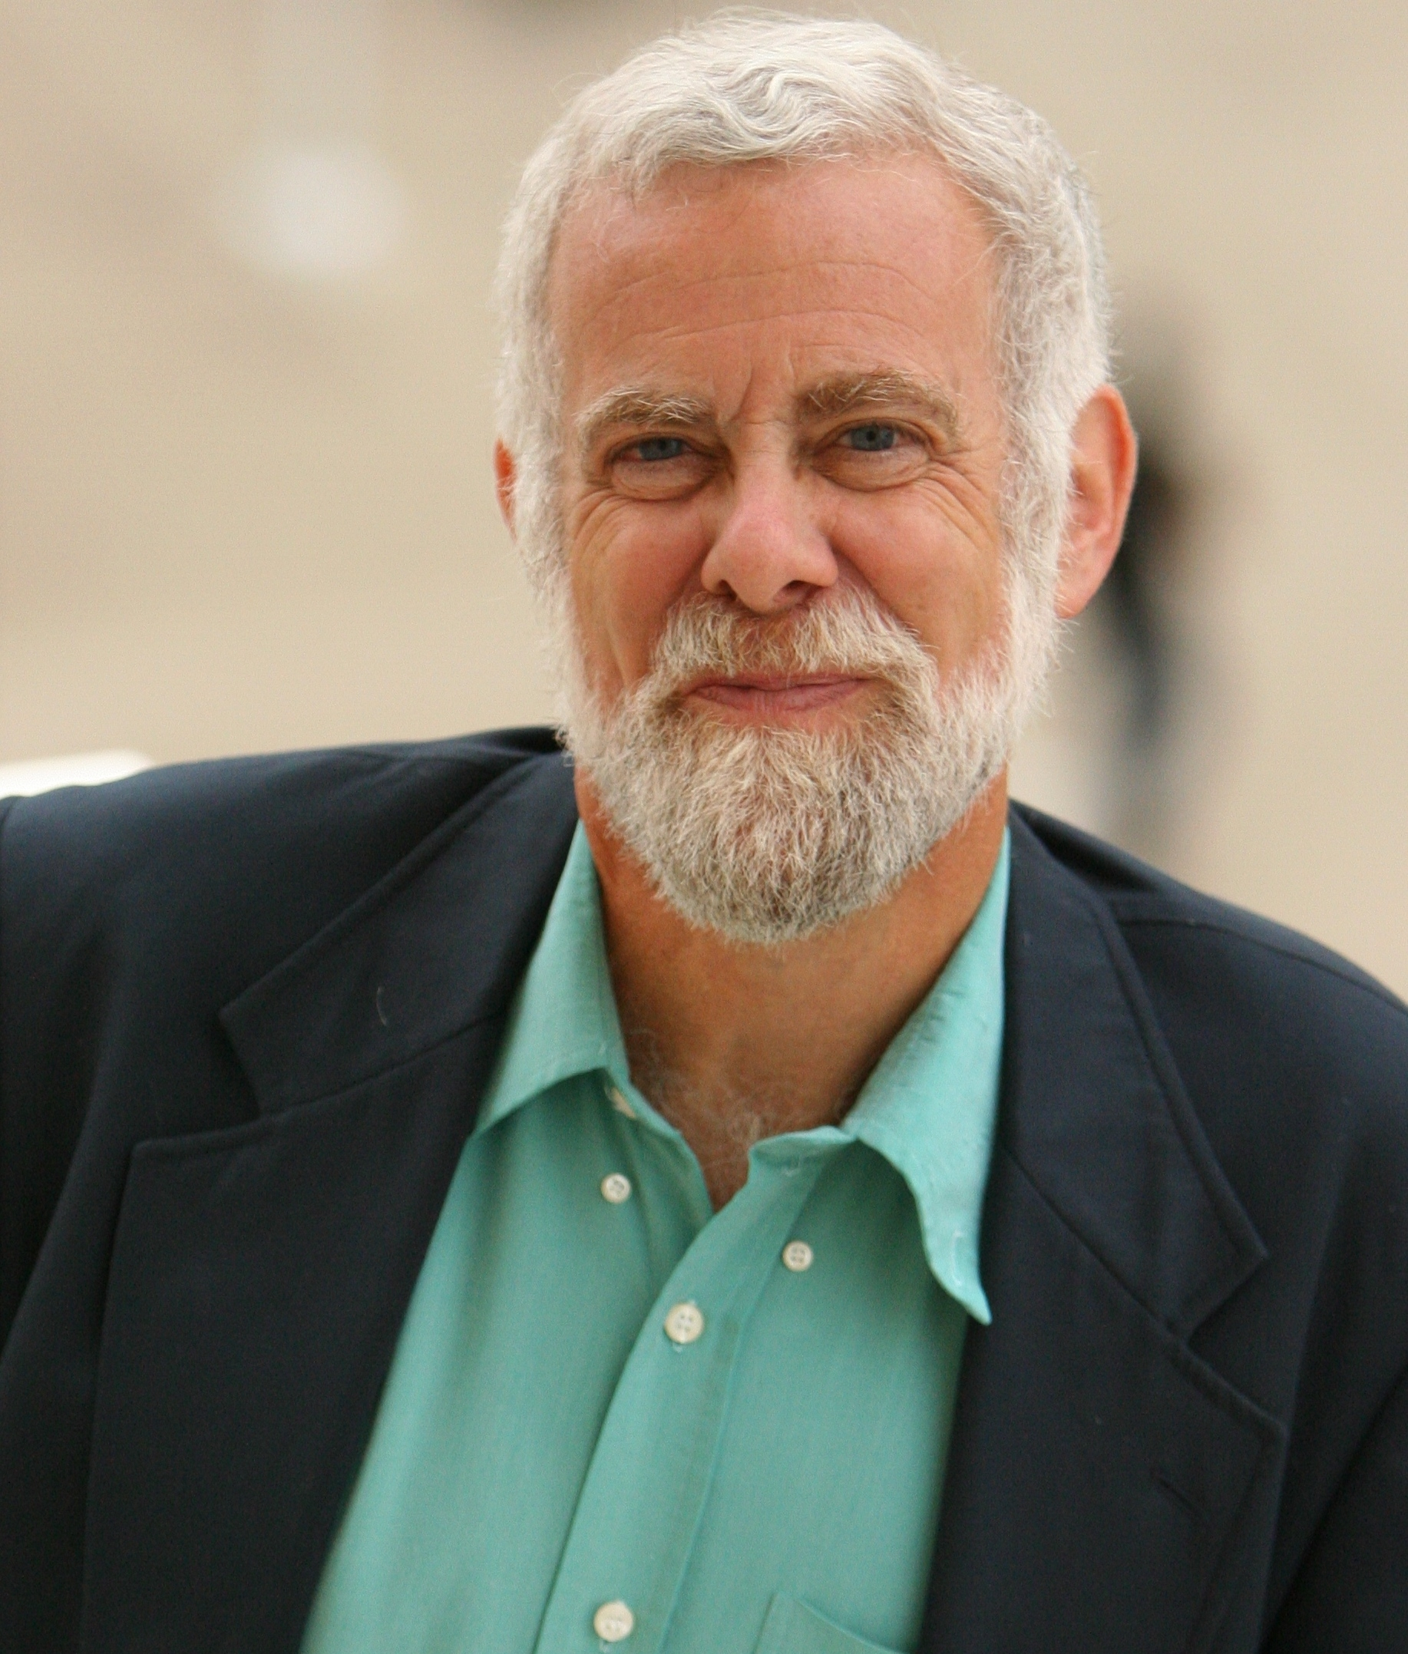
Carroll Seron
Editor (2008-2010) Law & Society Review.
David Smith
Editor, International Journal of Comparative Sociology (2010-present). Co-editor Contemporary Sociology (2005-2008).

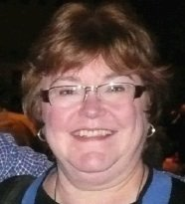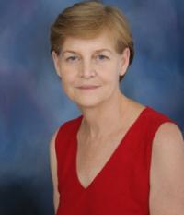
Judy Olson
Associate Editor, Transactions on Human-Computer Interaction (2006-present).
Martha Feldman
Senior Editor, Organization Science (2006-present).

COR
Center for Organizational Research

